|  |
| --- |
| Toiletries and hygiene items |
| Case Study: Net Revenue Management For HealthMax  [Document subtitle] |
| |  |  |  | | --- | --- | --- | | Khola Shams | 5/9/24 | Excel Case Study | |

Contents

**Introduction** 3

**1. Data Cleaning and Preparation** 3

1.1 Value Formatting and Data Organization 3

1.2 PivotTable Creation and Analysis 3

**2. Market Analysis** 3

2.1 Market Share Distribution 3

2.2 Profitability and Product Performance 3

**3. Promotional Effectiveness** 4

3.1 Promotion Analysis 4

**4. Sales Forecasting** 4

4.1 Forecasting Methodology 4

4.2 Forecasted Sales Figures 4

**5. Conclusion** 5

**6. Recommendations** 5

6.1 Product Strategy 5

6.2 Pricing and Promotion 5

6.3 Sales Forecasting and Planning 5

## **Introduction**

This report provides a comprehensive analysis of HealthMax’s shampoo category, focusing on Net Revenue Management (NRM) principles. The analysis includes market performance, product profitability, promotional effectiveness, and sales forecasting. The goal is to utilize advanced Excel techniques to derive actionable insights and strategic recommendations for optimizing market performance and revenue growth.

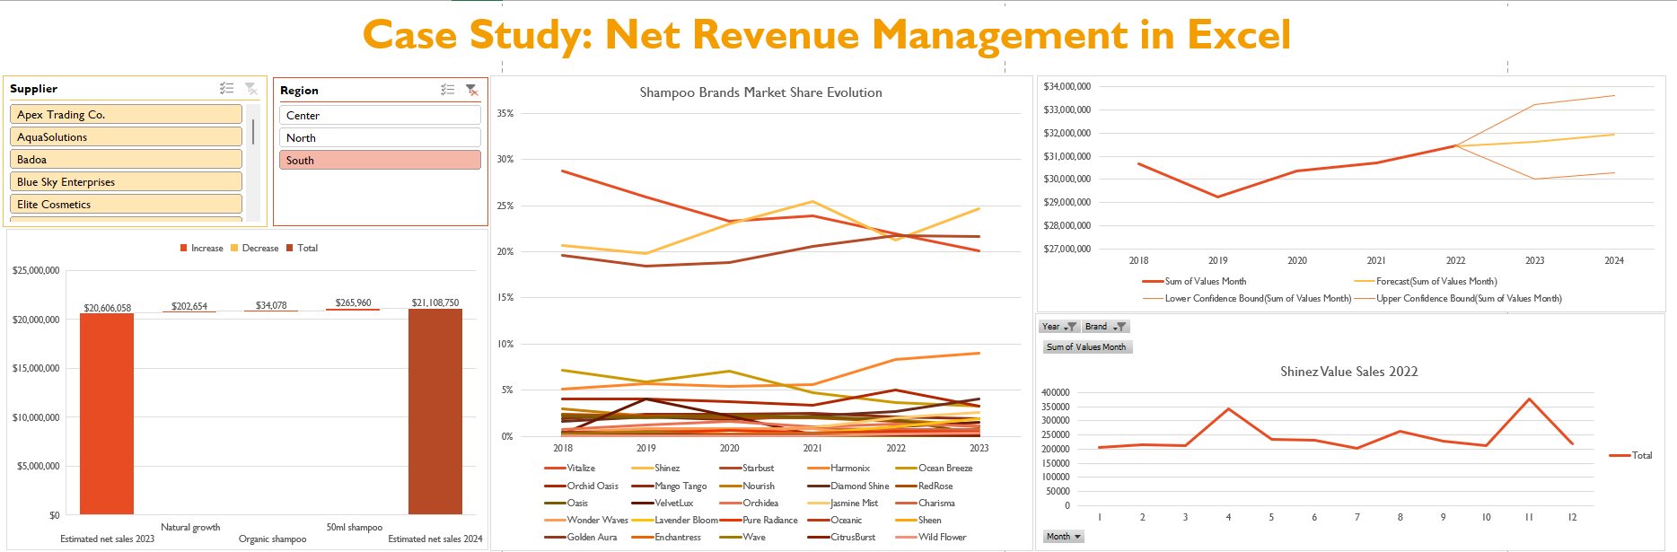

## **1. Data Cleaning and Preparation**

### 1.1 Value Formatting and Data Organization

The initial phase of the project involved significant data cleaning and reorganization. Value formatting issues were addressed by removing hardcoded dollar signs from the “Values Month” column and reformatting it into a standardized currency format. This step was crucial for accurate financial analysis and ensuring consistency across the dataset.

### 1.2 PivotTable Creation and Analysis

Multiple PivotTables were created to dissect various aspects of the data:

* Brands per Supplier: Provided a detailed breakdown of brands supplied by each supplier, helping to understand supplier relationships and brand distribution.
* HealthMax Growth: Focused on tracking value sales for HealthMax across different years. Growth comparisons were made to assess performance trends, highlighting how sales figures evolved over time.
* Units and Values YTD/MAT Calculations: Added columns for "Units YTD" and "Values YTD" using SUMIFS() functions to compute year-to-date and month-at-end (MAT) figures. These calculations are essential for evaluating overall sales performance and revenue trends.

## **2. Market Analysis**

### 2.1 Market Share Distribution

The market share analysis revealed significant variations in brand performance across different years. For instance:

* HerbEssentials: Consistently maintained a strong gross margin of 61%, indicating robust profitability and market position.
* Shinez: Despite a substantial share in several years, its profitability varied, with some promotional activities resulting in negative returns on investment (ROI).

The analysis identified key growth areas and underperforming categories. The increase in market share for Organic products suggests a shift towards natural and eco-friendly options, reflecting changing consumer preferences.

### 2.2 Profitability and Product Performance

The gross profit analysis highlighted:

* HerbEssentials**:** High gross profit per unit ($2.15) and total gross profit ($22,202.19). This brand exhibited strong profitability due to efficient cost management and effective pricing strategies.
* Herbashine: Although it showed a lower gross profit per unit ($1.85), its total gross profit ($22,925.05) was substantial, indicating high sales volume despite slightly lower margins.

Product performance by subcategory revealed significant declines in traditional categories such as Anti-dandruff and Color-safe. In contrast, Organic products exhibited impressive growth, emphasizing the need to focus on emerging trends and consumer demands.

## **3. Promotional Effectiveness**

### 3.1 Promotion Analysis

Promotional effectiveness was assessed by analyzing various marketing campaigns:

* Buy 2, Get 1 Free: This promotion for Shinez yielded a negative ROI of -79.91%, indicating that the promotion might not have been effective in driving incremental sales relative to its cost.
* Buy 2, Get 20% Off: Similar to the previous promotion, this also resulted in a negative ROI (-86.20%), suggesting that the discount did not sufficiently boost sales to cover the costs.
* 2nd at 50% Off: Although this promotion had a relatively higher ROI compared to others, it still resulted in a negative ROI of -70.60%, pointing to potential issues with the promotional strategy.

Monthly sales data for Shinez highlighted fluctuations throughout the year, with notable peaks and troughs. This variation underscores the importance of aligning promotional activities with seasonal trends and consumer purchasing behavior.

## **4. Sales Forecasting**

### 4.1 Forecasting Methodology

The sales forecasting involved analyzing historical sales data to predict future performance. Key components of the forecasting included:

* Historical Data Analysis: Past sales figures were used to identify trends and patterns, providing a basis for forecasting future sales.
* Statistical Modeling: Various statistical techniques and forecasting models were employed to estimate future sales. Confidence intervals were calculated to provide a range within which future sales are expected to fall.

### 4.2 Forecasted Sales Figures

* 2022 Actual Sales**:** $31,442,892
* 2023 Forecasted Sales: $31,635,324, with a confidence interval ranging from $30,014,004 to $33,256,644.
* 2024 Forecasted Sales: $31,946,448, with a confidence interval ranging from $30,274,836 to $33,618,060.

The forecasting indicates a stable sales trajectory with modest growth expectations. The confidence intervals reflect the uncertainty inherent in sales predictions, providing a range of potential outcomes.

## **5. Conclusion**

This in-depth analysis of HealthMax’s shampoo category highlights key performance metrics, identifies growth opportunities, and provides actionable insights. The data reveals areas of strength, such as the high profitability of Organic products, and areas needing attention, such as declining performance in Anti-dandruff and Color-safe categories. Sales forecasting indicates a stable growth trajectory, with clear expectations for future performance.

## **6. Recommendations**

### 6.1 Product Strategy

* Enhance Organic Product Line: Invest in research and development to expand the Organic product line. Focus on natural ingredients and eco-friendly packaging to appeal to the growing segment of environmentally conscious consumers.
* Reevaluate Underperforming Categories: Conduct consumer research to understand the declining interest in Anti-dandruff and Color-safe products. Consider product reformulation or targeted marketing campaigns to reinvigorate these categories.

### 6.2 Pricing and Promotion

* Implement Effective Promotions**:** Based on the promotional analysis, the “Buy 2, Get 20% Off” promotion was identified as having the highest profitability among the promotions analyzed. For the coming year, prioritize this promotion or similar offers that provide incremental value to customers while maintaining profitability.
* Revise Less Effective Promotions**:** Promotions such as “Buy 2, Get 1 Free” and “2nd at 50% Off” resulted in negative ROI. These strategies should be revised or replaced with more effective promotions to improve financial outcomes.

### 6.3 Sales Forecasting and Planning

* Adjust Production and Inventory**:** Use forecasting insights to align production schedules and inventory levels with expected sales. This will help manage the supply chain efficiently and reduce the risk of stockouts or overstocking.
* Monitor Forecast Accuracy: Continuously track actual sales against forecasts to evaluate forecasting accuracy. Adjust forecasting models as needed based on new data and market conditions to improve prediction reliability.